Student: Ianis Oprian
Calculatoare grupa 3

- Introduction

This documentation outlines the structure and execution of an Energy Management System (EMS), comprising a frontend application and three microservices. The system is engineered to oversee users and their linked smart energy metering devices. Users are categorized into two types: administrators (managers) and clients. Administrators possess the capability to execute CRUD operations on user accounts, smart energy metering devices, and oversee the association of users with devices.

- System Overview

The Energy Management System (EMS) uses the following components:
- Frontend Application: A user interface that provides access to the EMS for both administrators and clients.
- User Microservice: A microservice responsible for managing user accounts.
- Device Microservice: A microservice dedicated to managing smart energy metering devices.
- Monitor Microservice: A microservice responsible for managing sensor measurements and sending notifications
- Chat Microservice: A microservice responsible for mangaging web-socket communications between users and admins

- User Roles

The system defines two primary user roles:
- Administrator: has full control over user accounts, smart energy metering devices, and user-device mappings.
- Client: can access and manage their own smart energy metering devices.

- Functionality

  - Administrator Functions

Administrators can perform the following CRUD operations:
- Create, Read, Update, and Delete user accounts.
- Create, Read, Update, and Delete smart energy devices.
- Manage the mapping of users to devices, where each user can own one or more devices in different locations.
- Send messages to users

  - Client Functions

Clients can:
- View their own smart energy metering devices.
- Monitor the energy consumption of their devices.
- Send messages to the admin

- Microservice Architecture

The system employs a microservice architecture to ensure scalability, modularity, and maintainability.

User Microservice

This microservice manages user-related data, including user accounts and their roles.
Endpoints:
- Create User
- Read User
- Update User
- Delete User

Device Microservice
- This microservice manages information related to smart energy metering devices.
- Endpoints:
- Create Device
- Read Device
- Update Device
- Delete Device
- LinkUser to Device
- Unlink User from Device

Monitor Microservice

- This microservice manages information related to sensors
- Endpoints
- Create Message objects and stores them to db
- Creates and connects to WebSockets

Chat Microservice
- This microservice is responsible for sending messages using websocket functionalities
- Endpoints

- Non-Functional Requirements

The EMS is designed to meet the following non-functional requirements:
- Scalability: The system must accommodate an increasing amount of user and device data as it grows.
- Fast Response Time: The application must provide quick responses to user requests.
- Security: User data and privacy must be protected through robust authentication and authorization mechanisms.
- User-Friendly Interface: The frontend should have an intuitive and user-friendly design for easy navigation.

- Maintainability: The codebase must be well-documented and modular, allowing for easy modification and updates in the future.

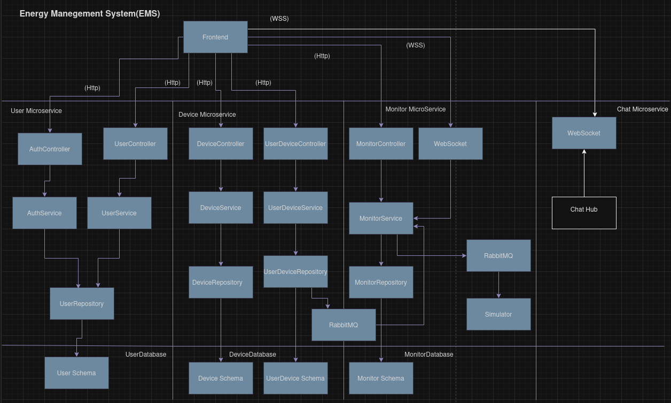

Deployment Architecture

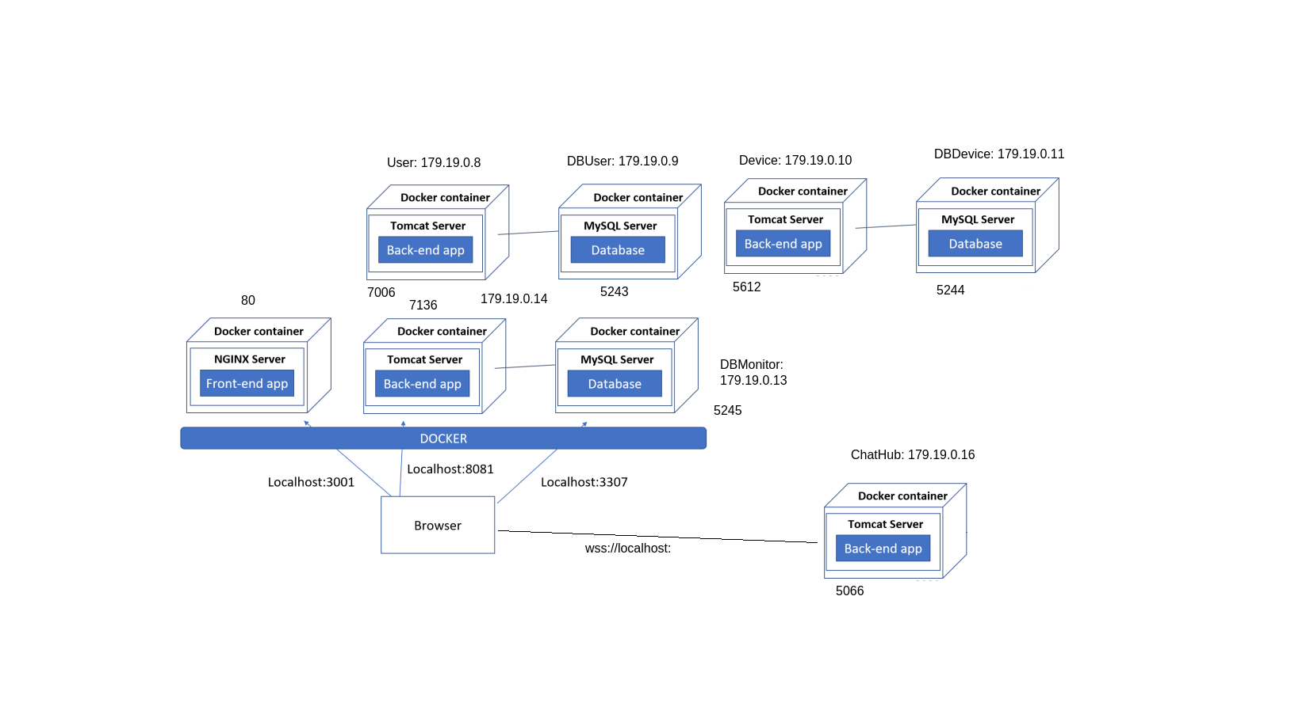

8. Bibliography

- https://angular.io/start
-https://dotnet.microsoft.com/en-us/languages/csharp
-https://www.javatpoint.com/net-framework
-https://learn.microsoft.com/en-us/dotnet/core/docker/build-container?tabs=linux&pivots=dotnet-7-0
-https://www.w3schools.com/html/default.asp
-https://www.w3schools.com/css/default.asp
-https://www.w3schools.com/js/default.asp

